Rabbit mq running as a backing service
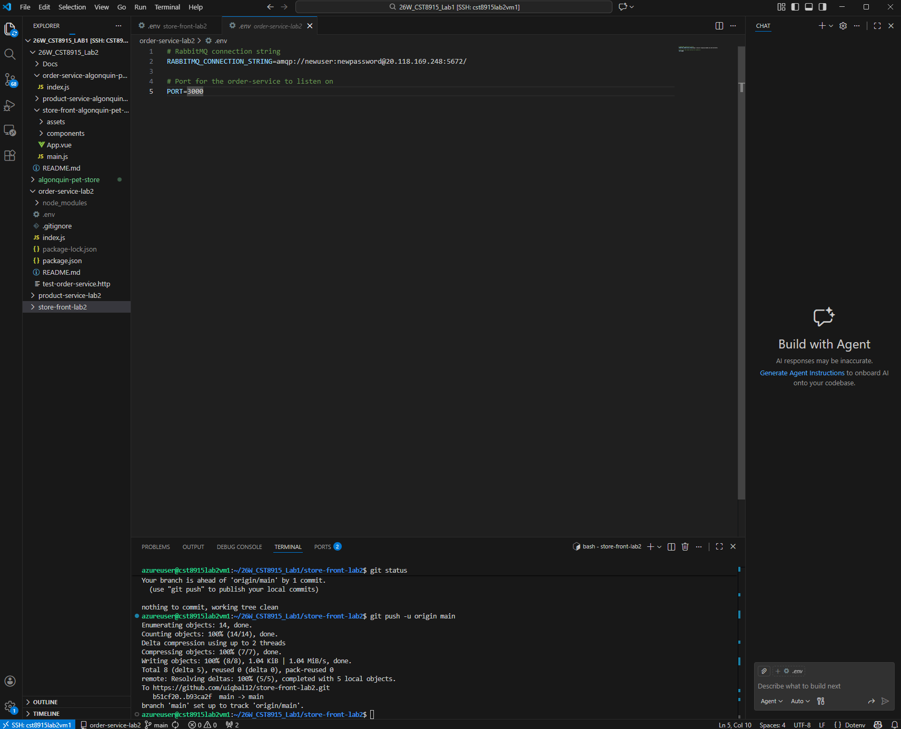

Order service running as its own repo and successful order received on rabbit mq

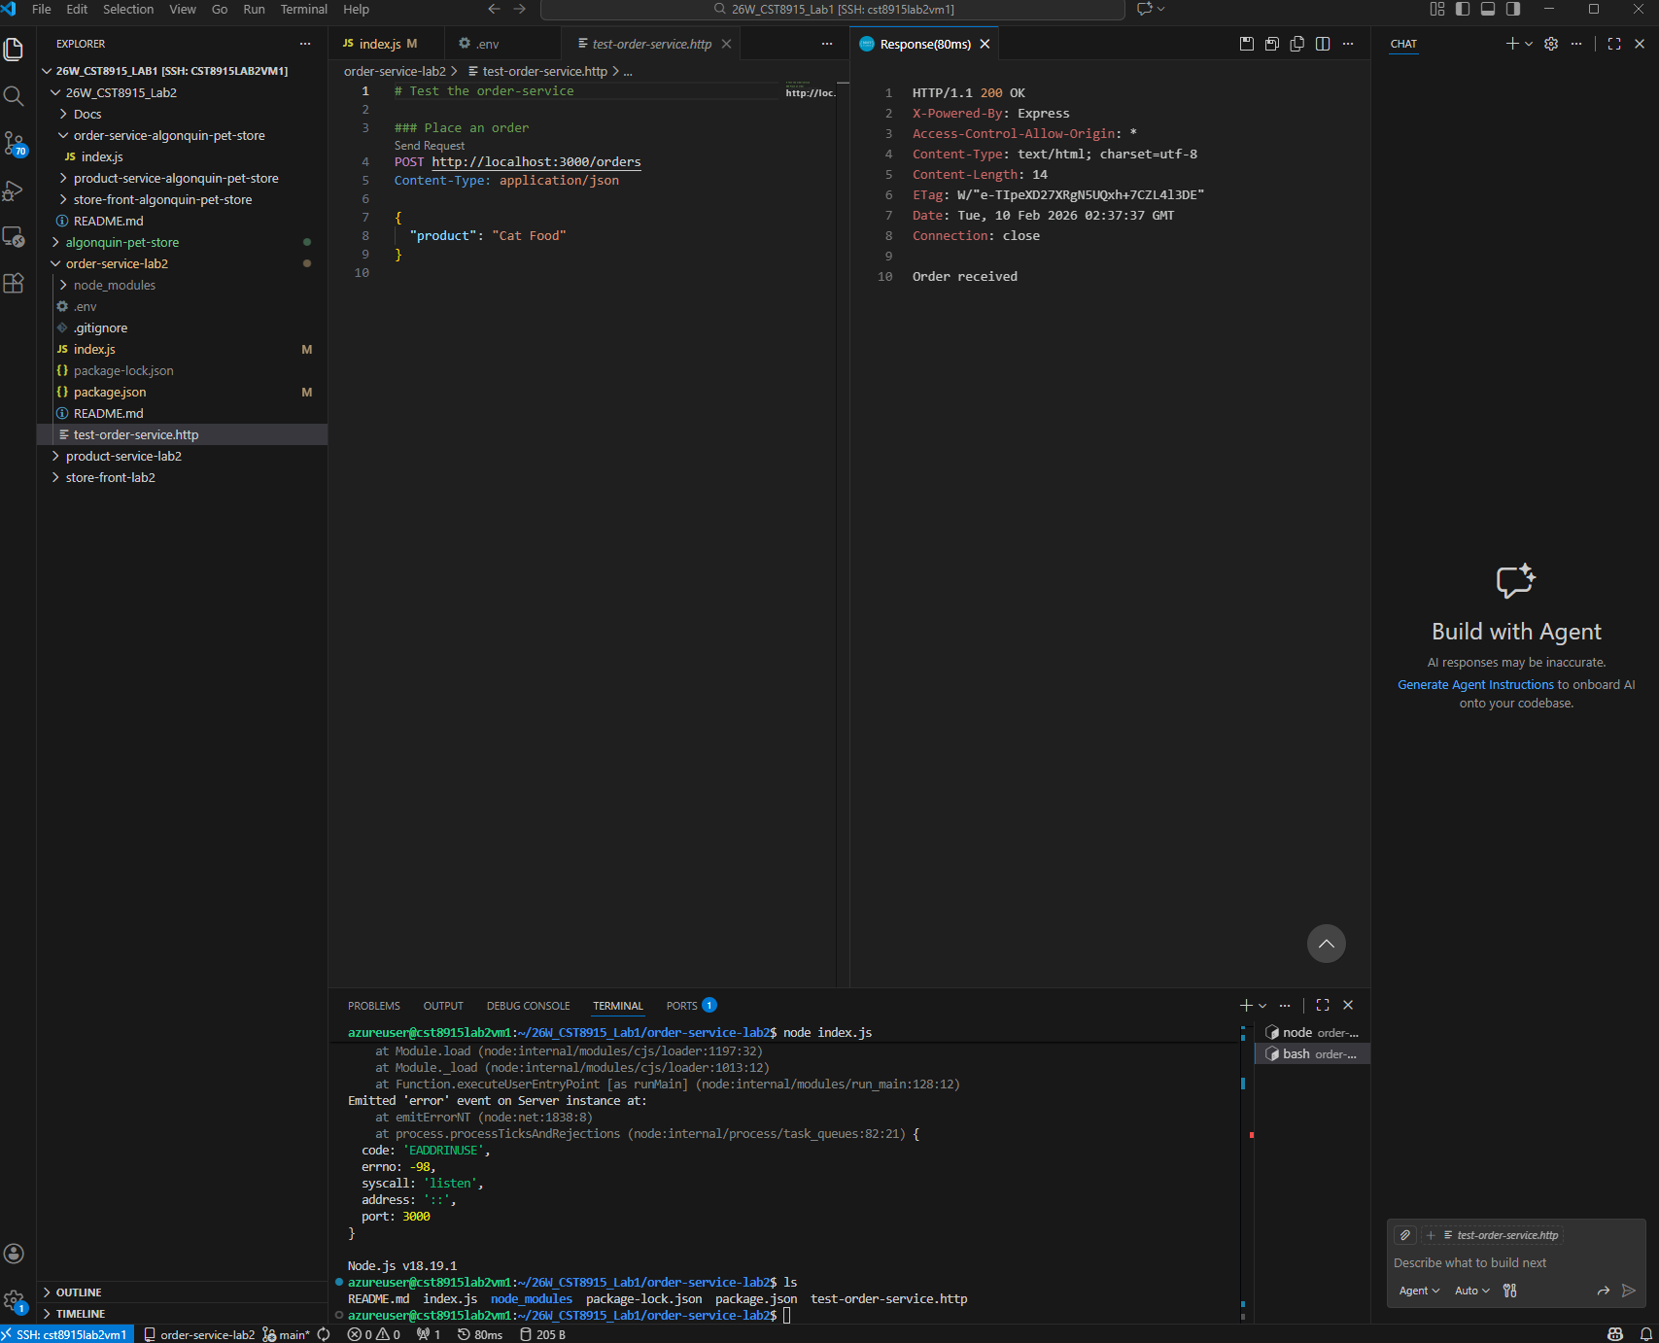

Product service running as its own repo and successful test
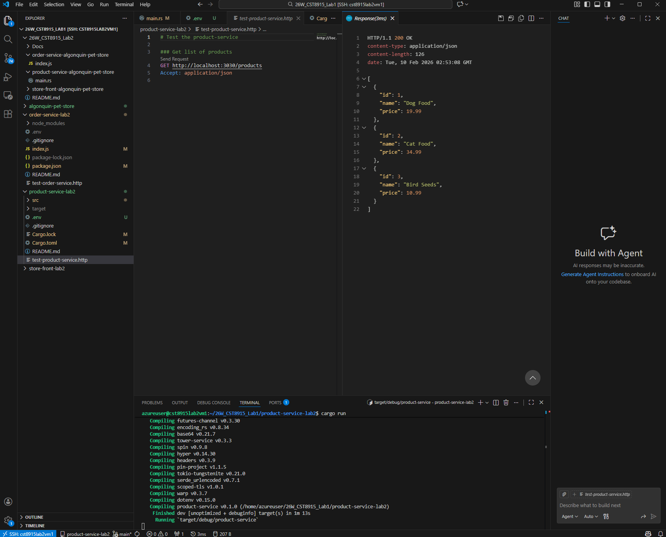
Rabbit mq is running on vm with ip address
20.118.169.248

Lab2 vm2 will run product service

Had to run the following commands
# Clear cached packages
sudo apt-get clean
sudo apt-get autoclean

# Update package lists
sudo apt-get update

# Try the installation again
sudo apt-get upgrade
# or
sudo apt-get install [your-package-name]

because cargo install was not working

after this it was running in its own vm as its own repo and successfully passed the rest client test
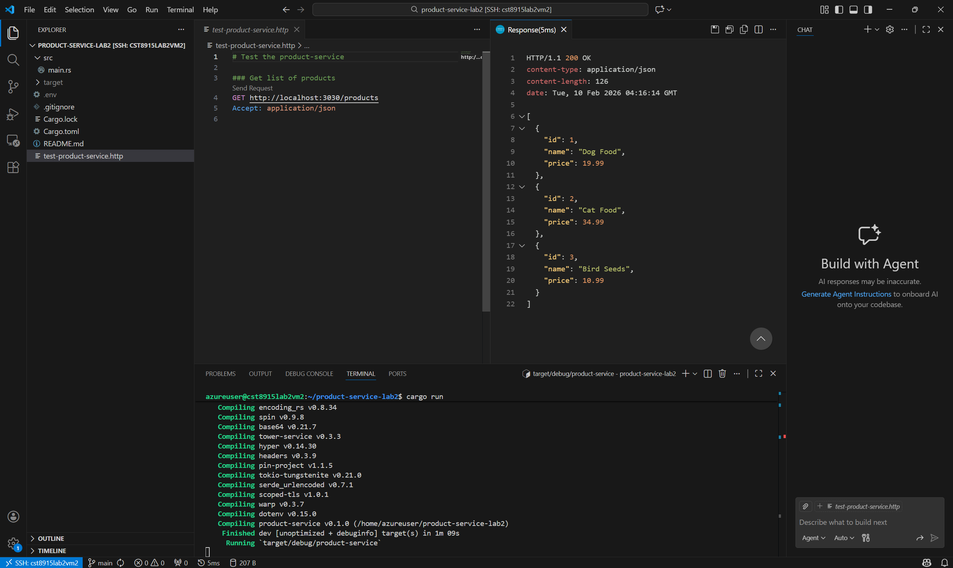

cst8915-lab2-vm3_key.pem
the last vm will house both order service and store front
cst8915lab2vm3_key_0209.pem

Host cst8915labvm1
HostName 20.150.139.243
User azureuser
IdentityFile C:\Users\usama\.ssh\cst8915labvm1_key.pem

Host cst8915lab2vm1
HostName 20.118.169.248
User azureuser
IdentityFile C:\Users\usama\.ssh\cst8915lab2vm1_key.pem

Host cst8915lab2vm2
HostName 172.182.194.138
User azureuser
IdentityFile C:\Users\usama\.ssh\cst8915lab2vm2_key.pem

Host cst8915lab2vm3
HostName 4.242.233.121
User azureuser
IdentityFile C:\Users\usama\.ssh\cst8915lab2vm3_key_0209.pem
Latest vm ip address:
20.38.4.173
Order service running on its own vm
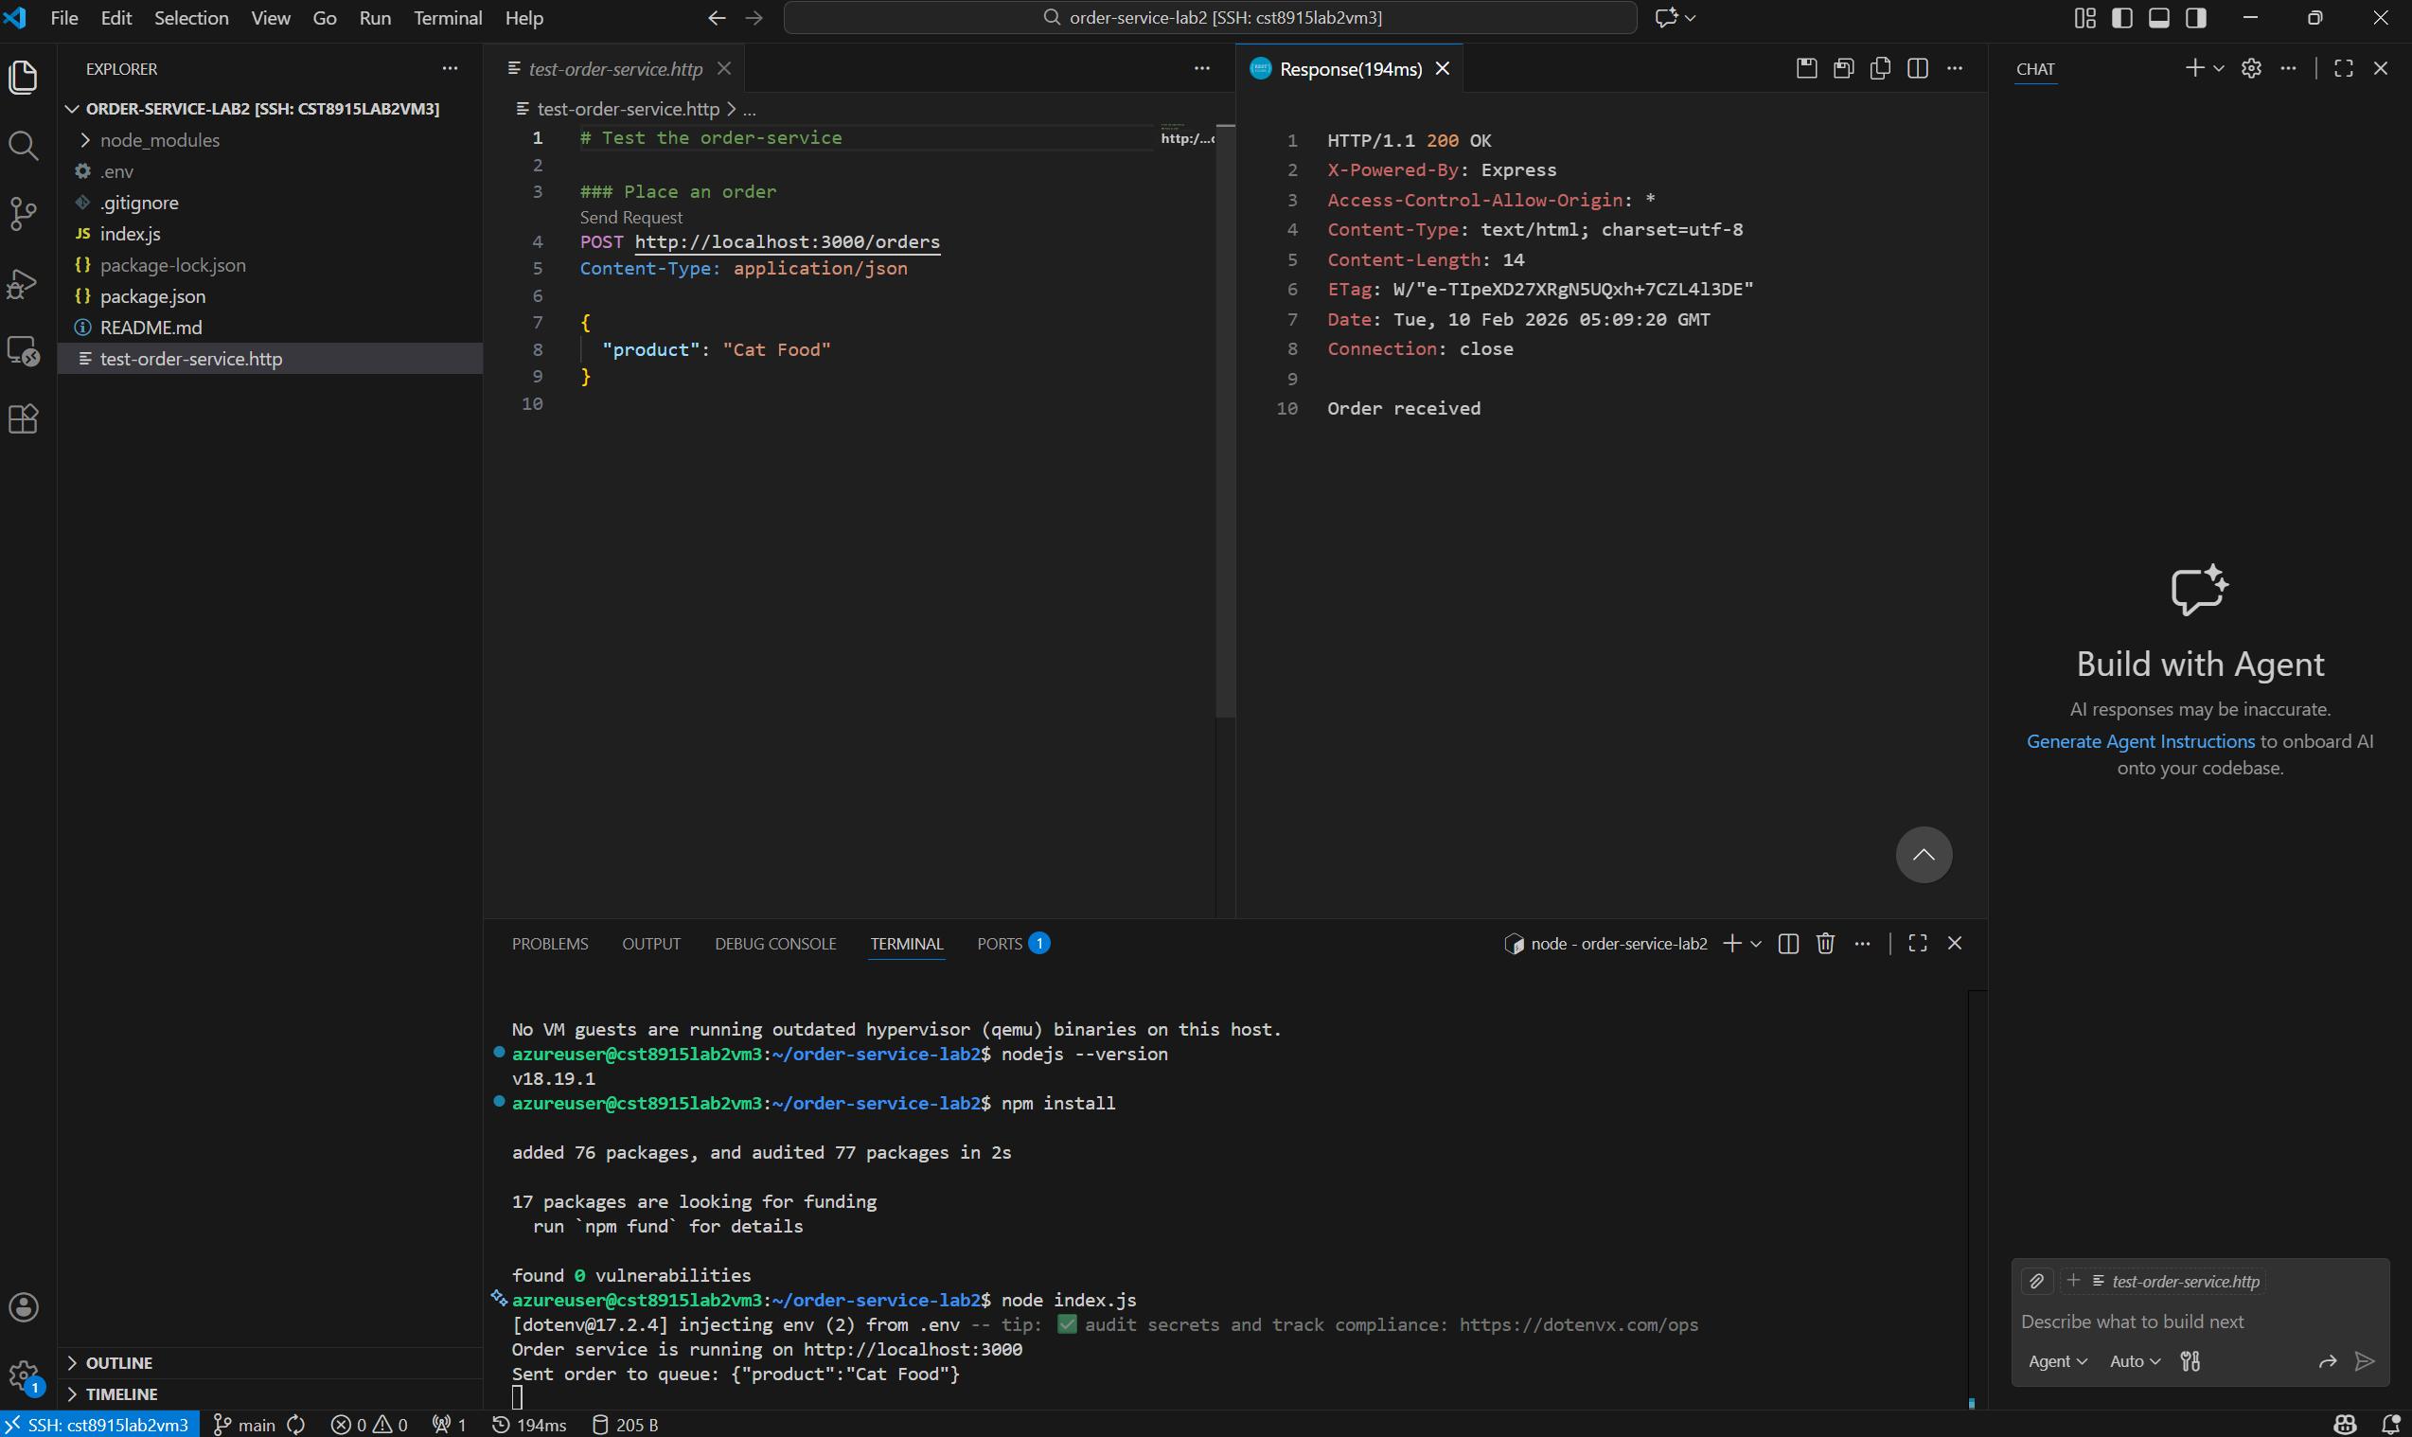

The order is working
